Swiggy Business Case:

**TASK 1.**

Identify date of highs and lows in the orders with respect to same day last week

|  |  |  |  |
| --- | --- | --- | --- |
| Order Change | % Change | Date | Day |
| Maximum order Change with respect to same day last week | 135.48% | 24-11-2019 | Sunday |
| Second maximum order Change with respect to same day last week | 135.03% | 23-07-2019 | Tuesday |
| Minimum order Change with respect to same day last week | -71.71% | 29-01-2019 | Tuesday |

**TASK 2.**

Change in traffic as compared to same day last week.

|  |  |  |
| --- | --- | --- |
| DATE | Change in Traffic compared to same to last week | Source |
| 10-01-2019 | -48.96% | Decrease in Facebook |
| 17-01-2019 | 110.20% | Increase in Facebook |
| 22-01-2019 | 76.53% | Increase in Facebook |
| 29-01-2019 | -40.46% | Decrease in Facebook and others |
| 20-06-2019 | -53.00% | Decrease in Facebook and YouTube |
| 27-06-2019 | 119.15% | Increase in Facebook, YouTube and others. |

The source of traffic change using Channel wise traffic sheet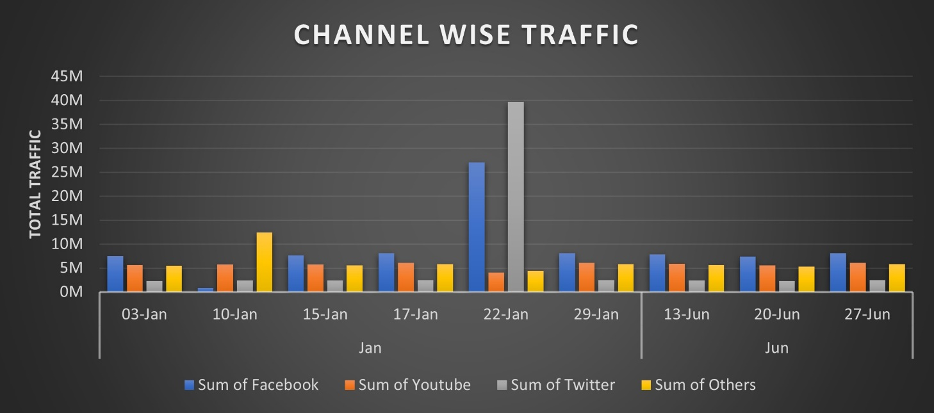 as shown in the graph.

From the above data, Facebook is one of the most important channel for traffic source.

**TASK 3.**

The Table below shows the dates with the maximum number of fluctuations in menu-to-cart conversions.

|  |  |  |  |
| --- | --- | --- | --- |
| Date | Day | Fluctuation Status | Reason |
| 19-02-2019 | Tue | Low | The supporting data indicates that the delivery charges are slightly higher than the average, but all other associated metrics are close to their respective averages. |
| 04-04-2019 | Thru | Low | Least discount compared to other days. |
| 18-04-2019 | Thru | High | Maximum discount. |
| 14-09-2019 | Sat | Low | Due to higher out of stock. |
| 17-11-2019 | Sun | Low | Maximum out of stock items per restaurant. |

**Reference**

The above data and chart was created with the help of Solution Sheet of Funnel Case Study data workbook.